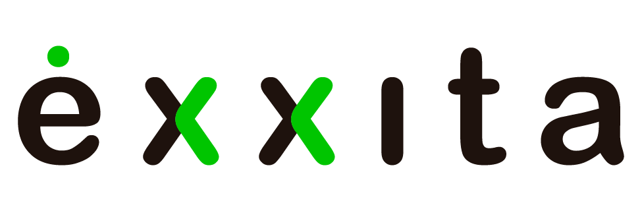
Exxita launches Spain's first pilot project to make the Right to Repair accessible to everyone
Developed in partnership with the Provincial Council of Gipuzkoa, the pilot project transforms the Right to Repair into an accessible public service through the iRepair Hub, an intelligent assisted-repair infrastructure developed by Exxita.
José Ignacio Asensio: "Gipuzkoa is once again positioning itself at the forefront of the circular economy by turning the Right to Repair into a public service that empowers citizens, tackles premature obsolescence and reduces electronic waste."
Gipuzkoa is once again reinforcing its position as a leader in sustainability and the circular economy with a pioneering initiative that transforms the Right to Repair into an accessible public service for everyone. Today, José Ignacio Asensio, Deputy for Sustainability; Mónica Pedreira, Director of Ecological Transition; and Silvia Matesanz, a member of Exxita's Advisory Board, presented the Right to Repair Gipuzkoa project—an innovative initiative that will enable citizens to repair, reuse and extend the lifespan of electronic products such as mobile phones, computers, tablets and smartwatches, helping to reduce electronic waste while promoting more responsible consumption.
As the first phase of the project, the Department of Sustainability will install the iRepair Hub in Plaza Gipuzkoa, San Sebastián.
The iRepair Hub is a local infrastructure that transforms the Right to Repair into an accessible, intelligent and fully traceable experience. Connected to Corely Intelligence, Exxita's proprietary intelligence layer, it assesses the condition of each electronic product and identifies the highest-value pathway to extend its lifecycle—repair, reuse, refurbishment or specialist intervention—before the product loses value or becomes waste.
During the presentation, José Ignacio Asensio highlighted:
"Today we are presenting much more than another circular economy initiative. We are introducing a new way of thinking about consumption, waste and citizens' rights. For too long, we have accepted that when a device stopped working, the only option was to replace it. With this project, we want to change that."
He also stressed that the initiative brings one of the European Union's newest rights into everyday life.
"A right only becomes meaningful when people have the means to exercise it. That is why Gipuzkoa is taking another step forward by launching a public service that makes repairing easier than replacing, helping citizens make informed decisions while protecting the environment."
A new public service to tackle premature obsolescence
The project has been conceived and developed by Exxita, a technology company specialising in Applied Intelligence for the Lifecycle of Electronic Products, and is being launched in Gipuzkoa thanks to the Provincial Council's commitment to making the Right to Repair an accessible public service. In doing so, Gipuzkoa positions itself as one of Europe's pioneering territories in the practical implementation of the new Right to Repair framework.
José Ignacio Asensio explained that the objective is to place technological innovation at the service of people and sustainability by providing, for the first time, a public infrastructure specifically designed to facilitate the repair of electronic products.
The iRepair Hub supports users throughout the entire process, from the initial assessment of the product through to its repair or recovery. The solution is built on Corely Intelligence, Exxita's proprietary intelligence layer, which analyses the product and recommends the most appropriate course of action in each case.
Users will be able to:
- identify their electronic product and obtain an initial assessment of its condition and the reported issue, in accordance with applicable European standards;
- receive guidance on the available options to extend its lifecycle;
- choose whether to leave the product in the secure collection module integrated into the iRepair Hub, where qualified professionals will carry out a full technical assessment and manage the process.
Once deposited, the electronic product will be collected by a certified technical service provider, which will carry out a professional diagnosis. Based on this assessment, users will receive a digital technical report and quotation, together with an objective recommendation on the highest-value alternative: repair, reuse, refurbishment or, only when no higher-value option exists, recycling.
If the quotation is accepted, the repair will be completed and the product returned to the same collection point.
The integrated digital solution ensures complete traceability throughout the process, allowing users to monitor the status of their electronic product from collection through to return.
Extending product lifecycles to reduce waste
The initiative seeks to reduce electronic waste by addressing the problem at its source: extending the lifecycle of electronic products before they become waste.
Asensio emphasised:
"The circular economy does not begin with recycling. It begins by extending the life of the products we already have. The most sustainable product is not the one that is recycled most efficiently, but the one that lasts the longest."
He also underlined that the project represents a shift in environmental policy.
"For years, we have worked to guarantee the right to recycle. Today, we are taking the next step by recognising the Right to Repair. We want a society where people have a genuine opportunity to repair before replacing, because protecting resources also means protecting people's rights."
Gipuzkoa strengthens its position as a leader in public innovation and the circular economy
Through this initiative, Gipuzkoa further reinforces its position as a benchmark for public innovation applied to sustainability, deploying advanced technological solutions to address one of today's most pressing environmental challenges: reducing the environmental impact of the growing consumption of electronic products.
The project is being launched as a pilot that will evaluate the service's performance while exploring its future expansion through a network of distributed infrastructures across the territory, bringing the Right to Repair closer to an increasing number of citizens.
As José Ignacio Asensio concluded:
"We want Gipuzkoa to continue serving as a laboratory for public innovation, where technology works in the service of sustainability and people. This project demonstrates that environmental policies can also be policies that protect rights, delivering practical solutions that improve people's lives while contributing to a more responsible, more circular and more sustainable territory."
San Sebastián, 24 July 2026

