Exxita Celebrates its Euronext Access Paris Listing with Ring the Bell Ceremony
The Seville-based technology company, listed on Euronext Access Paris, has a market capitalisation of €25.8 million and is strengthening its international expansion strategy
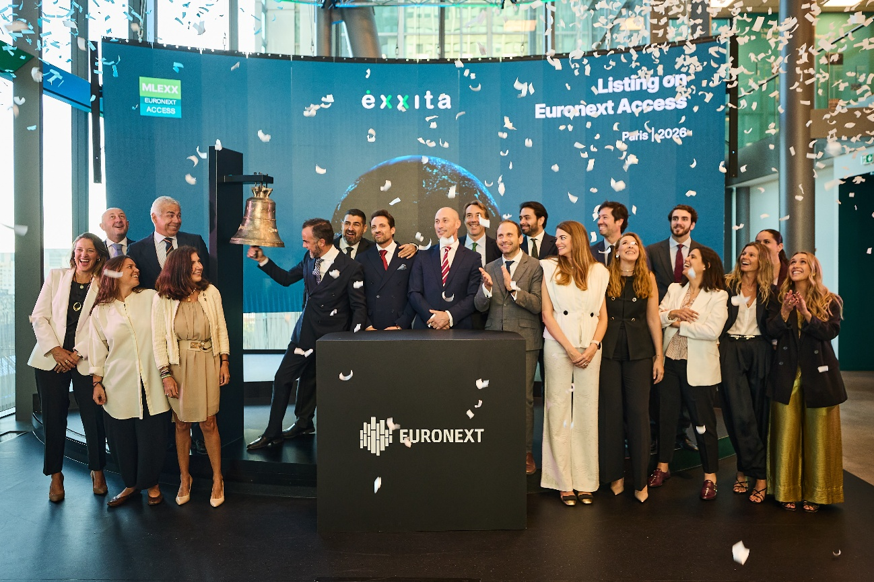
Exxita celebrates its listing on Euronext Access Paris with the traditional Ring the Bell ceremony in Paris.
Photo: Surfly Studio
Seville, 15 September 2026 – Exxita Be Circular, S.A. (“Exxita”), a Spanish technology company specialising in preserving and recovering the value of electronic products throughout their lifecycle, today celebrated its listing on Euronext Access Paris with the traditional Ring the Bell ceremony at Euronext in Paris, marking the beginning of a new chapter in the Company’s development.
At the time of admission, Exxita had a market capitalisation of €25.8 million, representing a further milestone for a company founded in Andalusia that, after more than two decades of industrial experience, is taking the next step in its growth and international expansion strategy.
Exxita’s shares were admitted to trading on Euronext Access Paris through the admission of the 88,797 existing shares comprising the Company’s share capital, at a reference price of €290.51 per share. The transaction was completed through a technical admission and did not involve the issuance of new shares.
Headquartered in Seville, Spain, Exxita employs approximately 160 people and operates more than 10,000 square metres of technical, logistics and industrial infrastructure. Over the past two decades, the Company has evolved from the industrial management of electronic products into a model where technology, data and the circular economy converge to extend product lifecycles and preserve as much value as possible before recycling becomes the final alternative.
In 2024 alone, Exxita managed the lifecycle of more than 500,000 electronic products and currently works with organisations including Telefónica, MediaMarkt, Lenovo, TCL and Alcatel-Lucent Enterprise.
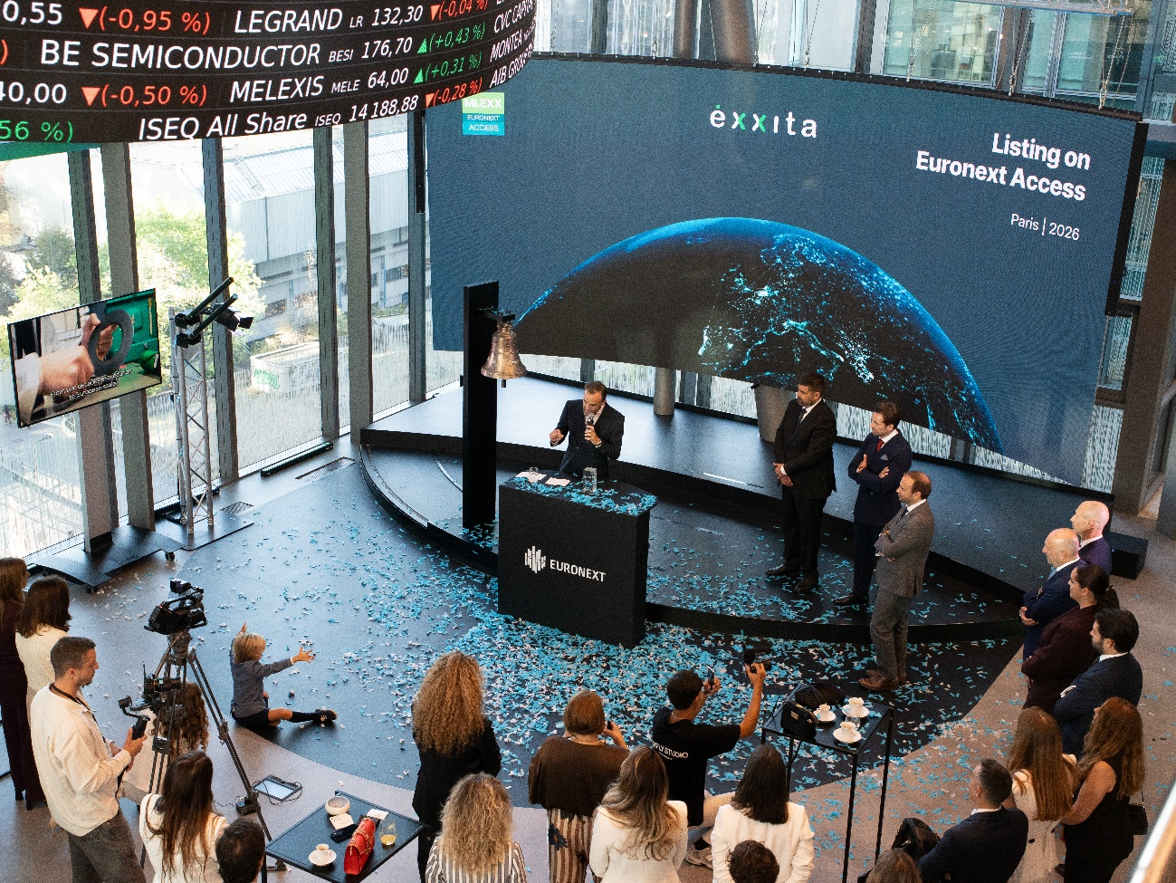
Exxita celebrates its listing on Euronext Access Paris with the traditional Ring the Bell ceremony in Paris.
Photo: Surfly Studio
From Seville to Europe
Exxita’s listing on Euronext Access Paris supports the next phase of the Company’s growth, with international expansion as one of its key strategic priorities.
France will be Exxita’s first priority market, as part of a broader European roadmap that also includes the Netherlands, Belgium, Austria, Norway and Poland.
France was selected due to the maturity of its circular economy ecosystem, combining advanced regulation, well-established Extended Producer Responsibility (EPR) schemes, the presence of major manufacturers and retailers, and an extensive network of public and private stakeholders involved in transforming the way products and resources are managed.
Alejandro Costa, Founder, Chairman and Chief Executive Officer of Exxita, said:
“Today’s ceremony represents much more than the celebration of our listing. It marks the beginning of a new chapter for Exxita as we accelerate our international expansion across Europe.”
Costa added that the Company’s evolution has been driven by an idea that has shaped its activity for more than twenty years: the key challenge is not simply managing waste, but preventing the premature loss of value from products.
This vision has driven the development of both Exxita’s industrial capabilities and Corely Intelligence, its proprietary technology designed to bring intelligence to decisions made throughout the lifecycle of electronic products.
“For more than twenty years, we have believed that the greatest challenge is not waste, but the loss of value. That belief has driven the development of our industrial operations and Corely Intelligence. Our admission to Euronext Access Paris gives us a stronger platform to scale this vision across Europe: making better decisions, preserving more value and generating greater economic, environmental and social impact.”
Rocío Blanco, Regional Minister for Employment, Enterprise and Self-Employment of the Regional Government of Andalusia, highlighted that Exxita’s admission to Euronext Access Paris “reflects the maturity of Andalusia’s technology ecosystem and the ability of our companies to grow and compete across Europe.”
Blanco noted that the Seville-based company has built from Andalusia an industrial and technological model focused on the circular economy. “Exxita’s growth is good news for Andalusia as a whole, because when a company from our region expands internationally and enters new markets, it also creates skilled employment, opportunities and future prospects,” she said. She added that the Company’s arrival on the Paris market “is a source of pride and an example of the talent, innovation and ambition of Andalusian companies.”
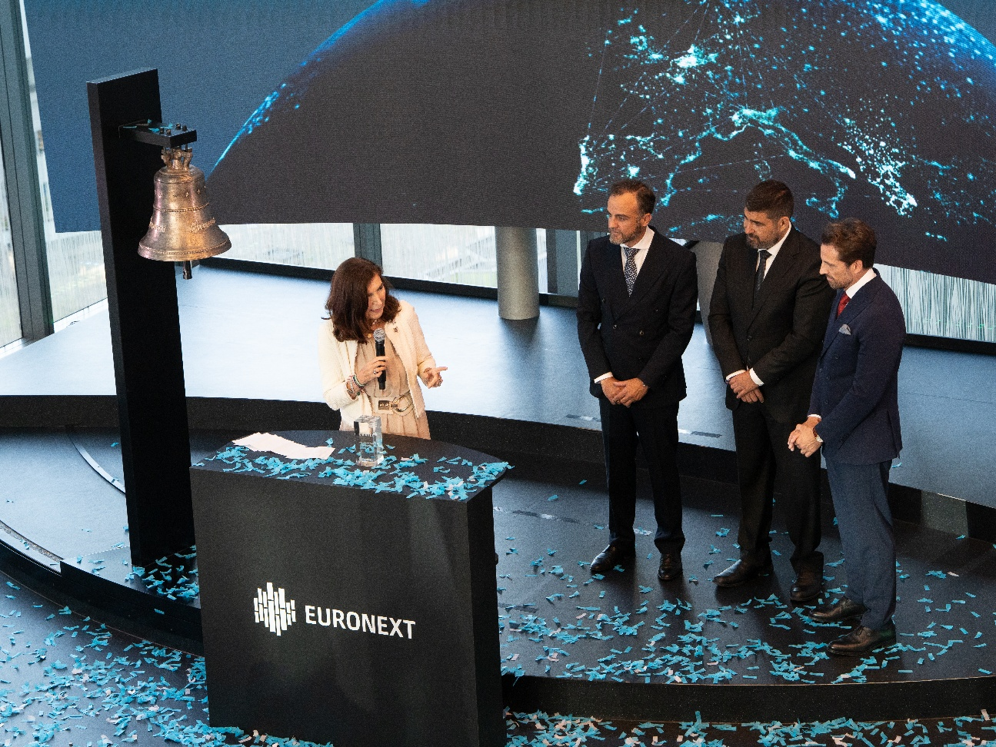
Exxita celebrates its listing on Euronext Access Paris with the traditional Ring the Bell ceremony in Paris.
Photo: Surfly Studio
Technology Transforming the Electronics Lifecycle
Exxita’s strategy is based on intervening before an electronic product becomes waste. To do so, the Company combines industrial operations, Lifecycle Value Management and Corely Intelligence, its proprietary intelligence layer.
This model enables Exxita to work with manufacturers, retailers, Producer Responsibility Organisations (PROs), recyclers, public institutions and consumers to determine which decision preserves the greatest possible value at each stage: repair, recovery, reuse, refurbishment or, when no other viable option remains, recycling.
Exxita calls this model Circularity Intelligence Infrastructure: an approach designed to transform the data generated throughout the management of each product into intelligence that can inform and improve future decisions.
Exxita’s listing on Euronext Access Paris therefore opens a new phase for the Company: scaling from Spain a technology-enabled industrial circular economy model with a European ambition.

CONTACTS
Exxita
Marina Entrambasaguas Real
Head of Communications & Executive Assistant
mentrambasaguas@exxita.com

About Exxita
Headquartered in Seville, Spain, Exxita is a technology-enabled circular economy company with more than two decades of industrial experience. It exists to preserve and extend the value of electronic products (Electrical and Electronic Equipment – EEE) throughout their lifecycle, before recycling becomes the only option left.
By combining industrial operations, Lifecycle Value Management and Corely Intelligence (its proprietary intelligence layer), Exxita helps manufacturers, retailers, Producer Responsibility Organisations (PROs), recyclers, public institutions and consumers make smarter lifecycle decisions and recover more value from products and resources already in circulation.
Every electronic product Exxita manages leaves behind more than materials: it leaves behind intelligence, and that intelligence gets smarter with every decision it informs. This is what Exxita calls Circularity Intelligence Infrastructure, an emerging category in Europe's circular economy. In 2024, Exxita managed the lifecycle of more than 500,000 electronic products and employed approximately 160 people. More information is available at www.exxita.com.

